

Information and Computer Science Department

[Leveraging Advanced Security Solutions to Mitigate IoT Device Vulnerabilities]
7.2, 7.3 & 7.4 Documentation
Team Members
[Hassan Hamzah AL-Amri, Musaad Ahmed AL-Anazi & Yasir S. Aldakhil Allah]
[G202306910, G202307070 & G202307250]
Mentors
[Dr. Waleed AL-Gobi]]

Submitted as part of the requirements for the SEC 619 for the Professional Mater of Cybersecurity
Term: 241, SEC 619: Project
[30] September 2024
Contents
3. Code Understanding: 2
3.1 Annotated Code Walkthrough: 2
3.2 Potential Improvement 8
3.3 Flow Diagram 8
4. Input and Output Demonstration: 10
4.1 Input and Output Mapping: 10
4.2 Test Cases: 12
4.3 Comparative Analysis 15
5 Validation: 16
5.1 Key Metrics: 16
5.2 Reproduced Results: 17

7.2. Code Understanding:

7.2.1 Annotated Code Walkthrough:
As highlighted earlier in our approach, we will focus on the part of the code that scan, detect and monitor the traffic of IoT Devices. This Python script is a GUI-based network tool for device discovery, traffic monitoring, and cryptographic analysis. Below, the code is divided into logical sections, with functionality, key components, and purpose explained for each section.
Part 1: Import Statements
import sys
from scapy.all import ARP, Ether, srp, sniff
from PyQt5.QtWidgets import (
QApplication, QWidget, QLabel, QLineEdit, QPushButton, QVBoxLayout, QHBoxLayout, QTableWidget, QTableWidgetItem, QCheckBox
)
from PyQt5.QtCore import Qt, QThread, pyqtSignal
from matplotlib.backends.backend_qt5agg import FigureCanvasQTAgg as FigureCanvas
from matplotlib.figure import Figure
import nmap
import time

Libraries Used:
- scapy: For packet crafting and network tasks like ARP requests, broadcasting, and sniffing.
- PyQt5: Constructs the GUI with widgets (input fields, buttons, tables, etc.).
- matplotlib: Visualizes real-time traffic data in a graph.
- nmap: Scans open ports for cryptographic analysis.
- sys and time: Handle system-level tasks and timestamping.
Purpose: Prepares the script with required modules for network operations, real-time visualization, and user interactions.

Part 2: Packet Sniffer Thread
class PacketSnifferThread(QThread):
packet_captured = pyqtSignal(int) # Signal to send captured packet size

def __init__(self, target_ips):
super().__init__()
self.target_ips = target_ips
self.running = True

def run(self):
sniff(prn=self.process_packet, stop_filter=self.should_stop)

def process_packet(self, packet):
if not self.running:
return False
if packet.haslayer("IP"):
src_ip = packet["IP"].src
dst_ip = packet["IP"].dst
length = len(packet)
if src_ip in self.target_ips or dst_ip in self.target_ips:
self.packet_captured.emit(length)

def should_stop(self, packet):
return not self.running

def stop(self):
self.running = False

Key Functions:
- QThread: Runs the sniffer in the background, keeping the GUI responsive.
- sniff: Captures network packets and filters them based on target IPs.
- packet_captured Signal: Communicates packet size to the GUI for real-time updates.
Purpose: Enables non-blocking, real-time monitoring of network traffic.

Part 3: Traffic Graph
class TrafficGraph(FigureCanvas):
def __init__(self):
self.figure = Figure()
super().__init__(self.figure)
self.ax = self.figure.add_subplot(111)
self.reset_graph()

def reset_graph(self):
self.ax.clear()
self.ax.set_title("Real-Time Traffic")
self.ax.set_xlabel("Time (s)")
self.ax.set_ylabel("Packet Size (bytes)")
self.ax.grid()
self.packet_sizes = []
self.timestamps = []
self.draw()

def update_graph(self, packet_size):
current_time = time.time()
self.timestamps.append(current_time)
self.packet_sizes.append(packet_size)
if len(self.timestamps) > 100:
self.timestamps = self.timestamps[-100:]
self.packet_sizes = self.packet_sizes[-100:]
self.ax.clear()
self.ax.plot(self.timestamps, self.packet_sizes, color="blue", marker="o")
self.draw()

Key Functions:
- reset_graph: Clears graph data, readying it for a new session.
- update_graph: Dynamically updates the graph with packet size and timestamp data.
Purpose: Visualizes live network traffic for analysis.

Part 4: GUI Initialization
class IntegratedApp(QWidget):
def __init__(self):
super().__init__()
self.initUI()

def initUI(self):
self.setWindowTitle("Integrated Network Tool with Traffic Graph and Cryptographic Details")
self.setGeometry(100, 100, 1200, 700)

self.ip_label = QLabel("Enter IP Range:")
self.ip_input = QLineEdit(self)
self.ip_input.setText("192.168.1.0/24")
self.scan_button = QPushButton("Scan for Devices", self)
self.scan_button.clicked.connect(self.scan_devices)

self.device_table = QTableWidget()
self.device_table.setColumnCount(3)
self.device_table.setHorizontalHeaderLabels(["Select", "IP Address", "MAC Address"])

self.traffic_graph = TrafficGraph()
self.start_monitoring_button = QPushButton("Start Monitoring", self)
self.stop_monitoring_button = QPushButton("Stop Monitoring", self)
self.crypto_button = QPushButton("Check Cryptographic Details", self)

main_layout = QVBoxLayout()
main_layout.addWidget(self.ip_label)
main_layout.addWidget(self.ip_input)
main_layout.addWidget(self.scan_button)
main_layout.addWidget(self.device_table)
main_layout.addWidget(self.traffic_graph)
self.setLayout(main_layout)

Key Functions:
- Widgets: Input field for IP range, buttons for scanning, monitoring, and cryptographic analysis, and a traffic graph.
- Layouts: Organizes widgets into a user-friendly structure.
Purpose: Creates an interactive interface for network analysis.
Part 5: Device Discovery
def scan_devices(self):
self.device_table.setRowCount(0)
ip_range = self.ip_input.text().strip()
arp_request = ARP(pdst=ip_range)
broadcast = Ether(dst="ff:ff:ff:ff:ff:ff")
arp_request_broadcast = broadcast / arp_request
answered, _ = srp(arp_request_broadcast, timeout=2, verbose=0)
for i, (sent, received) in enumerate(answered):
self.device_table.insertRow(i)
checkbox = QCheckBox()
self.device_table.setCellWidget(i, 0, checkbox)
self.device_table.setItem(i, 1, QTableWidgetItem(received.psrc))
self.device_table.setItem(i, 2, QTableWidgetItem(received.hwsrc))

Key Components:
- srp: Sends ARP packets and receives responses to discover devices in the specified IP range.
- Device Table: Displays discovered devices, including their IP and MAC addresses.
Purpose: Enables interactive network discovery.
Part 6: Packet Monitoring
def start_monitoring(self):
target_ips = [self.device_table.item(row, 1).text() for row in range(self.device_table.rowCount()) if self.device_table.cellWidget(row, 0).isChecked()]
self.sniffer_thread = PacketSnifferThread(target_ips)
self.sniffer_thread.packet_captured.connect(self.traffic_graph.update_graph)
self.sniffer_thread.start()

Key Components:
- Target IP Filtering: Monitors only selected devices from the table.
- Sniffer Integration: Starts a thread for real-time packet monitoring.
Purpose: Captures and visualizes network traffic dynamically.

Part 7: Cryptographic Analysis
def check_cryptographic_details(self):
selected_ips = [self.device_table.item(row, 1).text() for row in range(self.device_table.rowCount()) if self.device_table.cellWidget(row, 0).isChecked()]
nm = nmap.PortScanner()
for ip in selected_ips:
nm.scan(ip, arguments='-p 1-1000')
open_ports = [port for port, data in nm[ip]['tcp'].items() if data['state'] == 'open']
if 443 in open_ports:
print(f"{ip}: Strong Encryption")
elif 80 in open_ports:
print(f"{ip}: Weak Encryption")

Key Components:
- Port Scanning: Identifies open ports and infers encryption protocols (e.g., HTTPS or HTTP).
- Results Display: Outputs encryption strength for selected devices.
Purpose: Evaluates the security posture of devices in the network.
Part 8: Application Execution
if __name__ == "__main__":
app = QApplication(sys.argv)
window = IntegratedApp()
window.show()
sys.exit(app.exec_())

Key Components:
- QApplication: Starts the PyQt5 application.
- Event Loop: Keeps the GUI responsive.
Purpose: Launches the network analysis tool.

7.2.2 Potential Improvement
For the improvement of the presented network tool code, we plan to add new features that will be dedicated to IoT devices. These improvements include: (1) Identifying the OS of IoT devices, which is crucial for the identification of subsequent analyses. Most IoT devices run on lightweight or even custom operating systems, and knowing which OS was detected allows to focus on the vulnerabilities of the specific OS that were detected. It also points out old or non-supported systems which are vulnerable to attacks and can be used to make administrators prevent risks. (2) To Discover open ports for IoT devices is a crucial aspect in order to determine the level of vulnerability of a device to an attack. Open ports are the points through which an attacker can gain access and may expose services that are configured wrongly, are vulnerable or not required. Identifying open ports will help the user to close unnecessary ports, thereby minimizing exposure while focusing on threats associated with certain standard vulnerabilities in certain protocols or services. This is done through: (3) performing vulnerability scans based on the OS and open ports that have been identified, which makes it possible to undertake a more focused and detailed approach to security. This feature takes the OS detection and port scanning results and presents specific dangers that are more useful for countermeasures. It can be used for such aggressive defense measures as fixing a critical weakness, quarantining risky devices, or turning off hazardous services. Altogether, these features add up to a rather vast expansion of the code’s applicability to IoT device analysis and network security monitoring, which is necessary due to the increasing IoT devices security vulnerability, as many of the devices lack proper protection.

7.2.3 Flow Diagram
The flowchart outlines the process of scanning, monitoring, and analyzing network traffic or devices. The detailed breakdown of the flow is:
1. Start Process
The flow begins with the Start node.
2. Input IP Range
Enter IP Range: The user inputs the range of IP addresses to scan.
A check is performed to verify if the entered IP range is within range:
Out of Range: If the range is invalid, the user is redirected to enter the range again.
Within Range: If valid, the process proceeds.

3. Scan for Devices
Click Scan for Devices: The system scans the entered IP range for devices.
Devices Discovered: Once devices are identified, the system lists them.
4. Select Device
User Selects Device: The user chooses a specific device for further actions.
5. Start Monitoring
Start Monitoring: The system initiates monitoring on the selected device.
6. Check Cryptographic Details
The system analyzes the device’s cryptographic details and evaluates them.
7. Evaluate Network Configurations
Supported Network Configurations?: The system checks if the network configuration is compatible.
Yes: If supported, proceed to check traffic.
Show Real-Time Traffic: Displays real-time traffic if data is available.
No Traffic: If no data is found, the user is informed.
Stop Monitoring: The user can stop monitoring after reviewing results.
No: If unsupported, proceed to evaluate needed packets.
8. Check Packet Details
Needed Packets Exist?: The system determines if necessary packet data is available.
Yes: If packets exist, the system:
Show Cryptographic Details Result: Displays a detailed analysis of cryptographic data.
No: If packets are missing, the system:
Show "Unknown" or "Error": Informs the user that the analysis could not be completed.
9. End Process
The process concludes at the End node, either after monitoring and analysis are complete or due to an error.
Key Pathways
Valid flow: Enter IP → Scan → Select Device → Start Monitoring → Show Results → Stop Monitoring.
Error handling: Invalid range, unsupported network configurations, or missing packet data lead to error reporting.
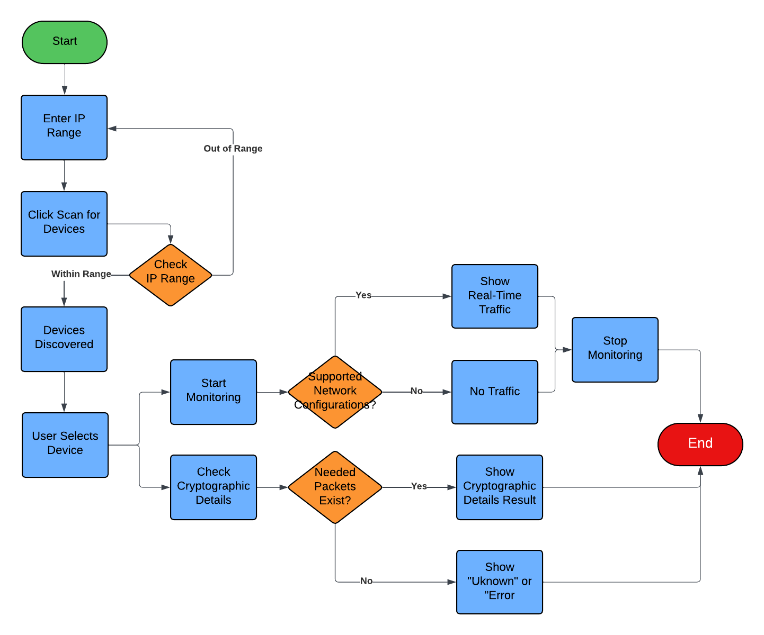
Figure 5: High Level Flow Diagram.

7.3 Input and Output Demonstration:

7.3.1 Input and Output Mapping:
To learn the provided inputs, it is crucial to get the correspondence to certain functions within the code and define the outcomes which are to be expected. The following functions focus on mapping inputs to the code and specifying the outputs as follows:

Function #1: Scan for devices
- Input: IP Range
- Output: List of devices within the specified IP range, including their IP and MAC addresses. The devices that are connected are recognized by this functionality with ARP (Address Resolution Protocol). A broadcast request is transmitted over a specified range for responses and is used to fill devices found list of tables.
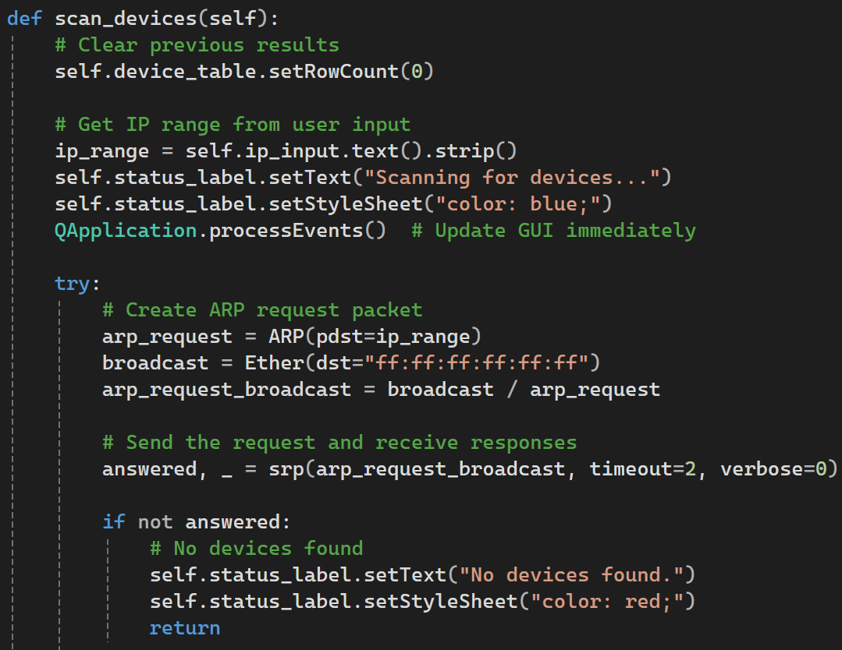
Figure 6: Code of First Function.

Function #2: Check port number to provide encryption details.
- Input: Open ports for the devices.
- Output: Encryption details and classifications (e.g., strong, weak, or unknown encryption). This function employs the nmap library to identify ports that are open on devices and estimate the kind of encryption on the corresponding ports. For instance, HTTPS and SSSH stand for high encryption while http and telnet stand for low or no encryption respectively.
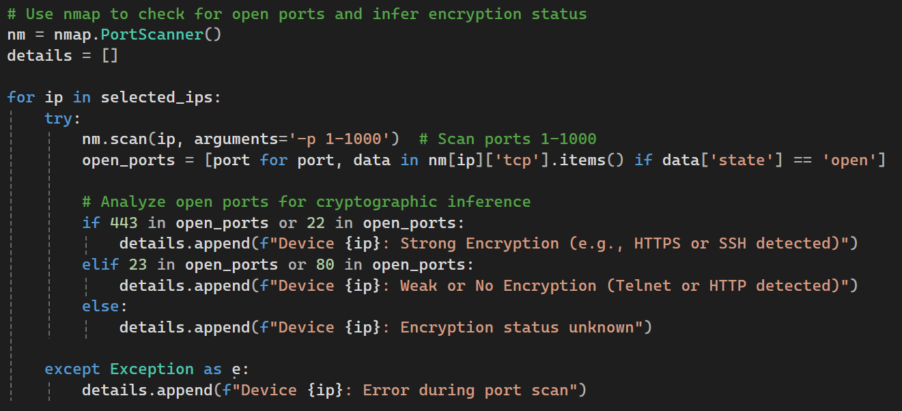
Figure 7 Code of Second Function.
Function #3: Monitor the device network traffic
- Input: one of discovered devices
- Output: Real-time traffic graph showing packet sizes and trends. This feature enables users to track the traffic of the network by specific devices. Packet data is plotted graphically and refreshed in real time to allow the user to easily detect abnormally high or low activity, which may indicate an intrusion.

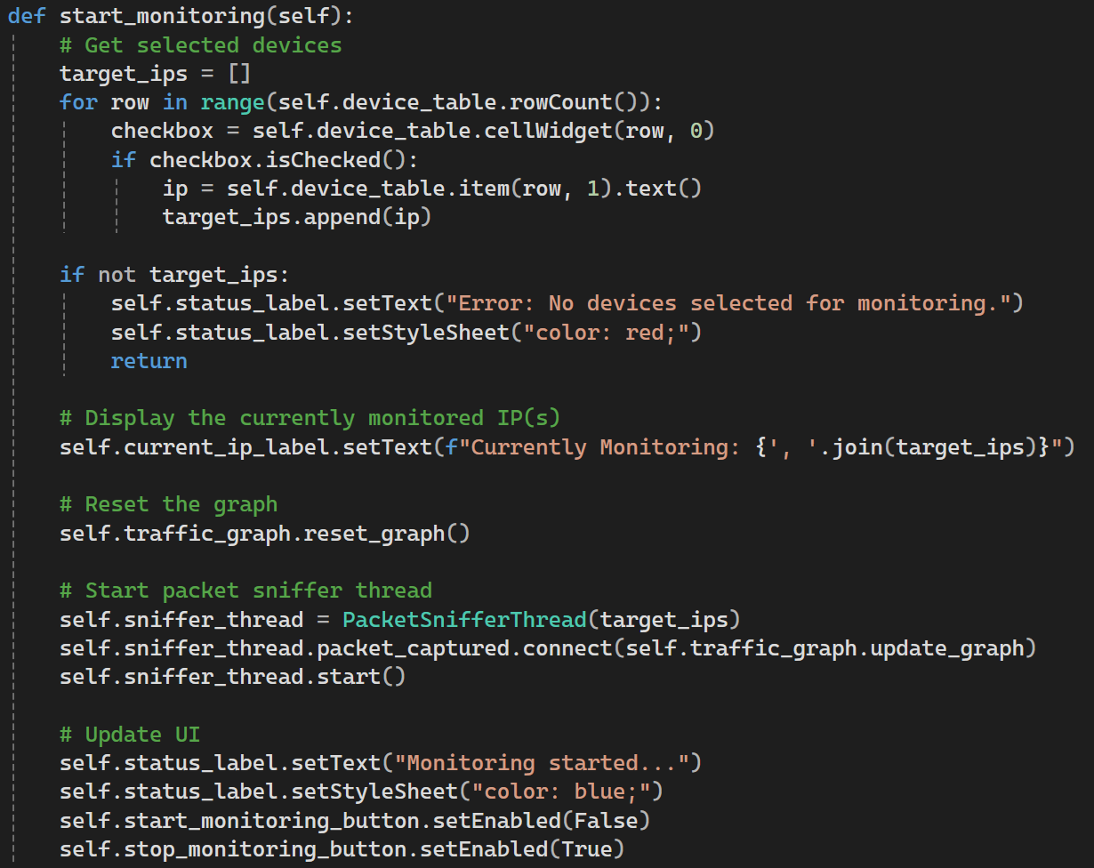
Figure 8 Code of Third Function.

7.3.2 Test Cases:

Test Case 1: scanning for devices within specific known DHCP IP range for router device will work perfectly without missing any device :
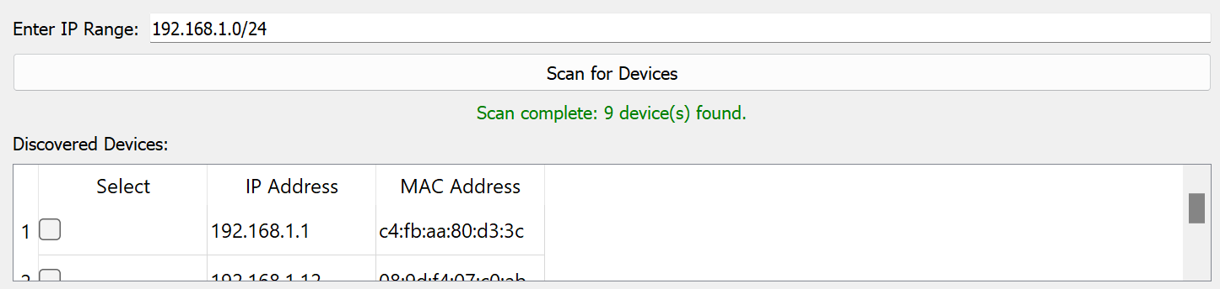
Figure 9: Scanning Devices.
But if you don’t know the DHCP range you will get no devices :
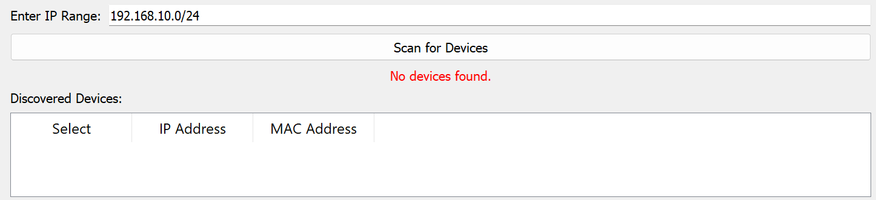
Figure 10: No Device Found.
Test Case 2: it depends on discovered device network configurations and operating system to apply network traffic monitoring , meaning if you select device to start monitoring for its network traffic you will not always see the output.
Here we can see the network traffic for selected device :

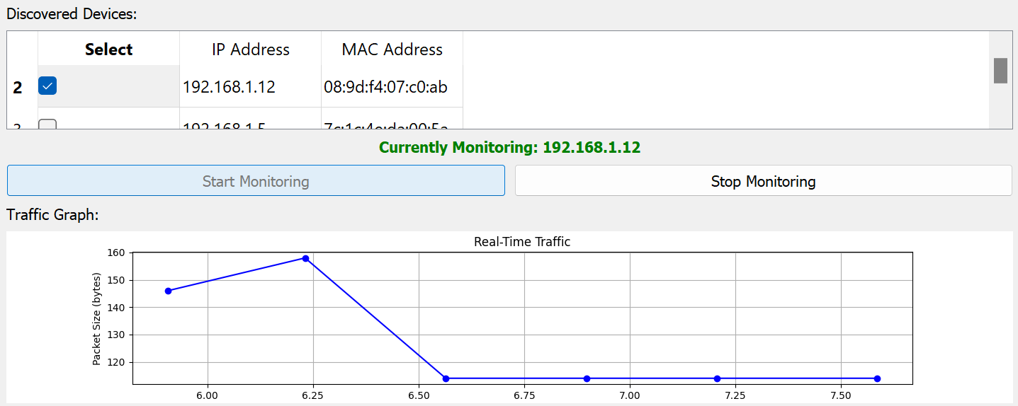
Figure 11: Capturing Traffic.
But here no data for traffic of this device:
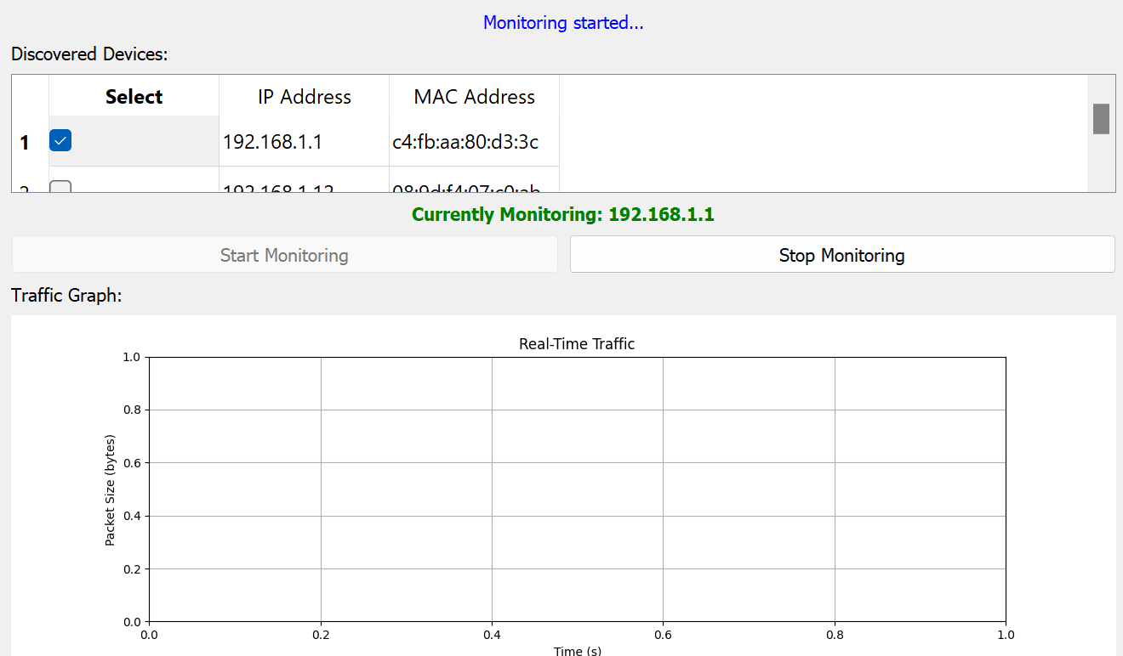
Figure 12: No Traffic Capture.

Test Case 3: cryptographic detail depends on captured specific captured packets (like Handshake) so if the specific packets not captured the cryptographic details will not shown :
example for device with detected cryptographic details :
Figure 13: Checking Device Cryptographic example 1.
And here is example for device with Unknown cryptographic details :
Figure 14: Checking Device Cryptographic example 2.
Or you may get Error:
Figure 15: Checking Device Cryptographic example 3.

7.3.3 Comparative Analysis
The Reproduced Code and IoT Inspector share many similarities in their approach to IoT device scanning, traffic capturing, and cryptographic analysis. Both tools use ARP scan to find devices within a local network by sending ARP requests to all IPs within a specified range. This technique is actually very useful to discover active devices and also to gather some important information like IP and MAC addresses. This first approach of scanning provides the best and most extensive view of the network, and users can easily find and investigate IoT devices. The Reproduced Code demonstrates this feature in a basic way for smaller scale environments and IoT Inspector applies the same concept but with a higher level of scalability and adaptability for real-world IoT devices.
For traffic capturing both tools use ARP spoofing – technique, which helps to intercept communication between devices and their routers with the help of positioning the tool as a router itself. This approach captures data packets in real time, allowing for the observation of IoT device traffic in high granularity. The Reproduced Code displays this captured data in real time graphical format like packet size against time during monitoring sessions to enable users to analyze the behavior of the device and the communication patterns. There is also an ability for users to turn on and off the monitoring at any time they wish. As for the further development of this functionality, IoT Inspector continues the work of intercepted packets by preprocessing them and converting raw data into more useful statistics and visualizations. IoT Inspector is designed for large-scale research and shares the real-time data focus of BigML, while also offering additional features such as automated data processing and anonymization to protect privacy.

In the area of cryptographical analysis, both are capable of computing encryption protocols and generating checklists of possible weaknesses. The Reproduced Code accomplishes these checks by checking open ports on IoT devices and categorizing the protocols that it finds, including HTTPS for secure connections, HTTP and Telnet for insecure connections. IoT Inspector is more specific by examining the TLS ClientHello messages, which lets it identify certain issues like the use of TLS 1.0 or 1.1 or RC4 cipher. While both tools are capable of identifying secured implementation and reporting on the available security flaws, IoT Inspector has a more specific target at cryptographic configuration, which allows for a finer insight into the identified threats, including specific downgrade attack scenarios. This comprehensive analysis makes sure that both tools are able to detect cases of poor encryption as it improves the general IoT security evaluation.

In conclusion, the Reproduced Code is intentionally intended as a selective testing environment to confirm and reproduce the major functions of IoT Inspector, which is a selective implementation of the framework for evaluating specific options including device scanning, traffic capture and cryptographic analysis. This limited focus guarantees that the outputs are consistent with IoT Inspector’s more extensive, actual outcomes, thereby validating the IoT Inspector’s conclusions while offering a basic structure for experimental verification.

7.4 Validation:

7.4.1 Key Metrics:
1. Detection Rate
- Definition: Measures the percentage of IoT devices or vulnerabilities accurately identified by the tool.
- Formula:
Detection Rate = $\left(\frac{Correct Detections}{Total Target Instances}\right)x 100$
- Goal: Achieve a high detection rate (e.g., ≥ 90%) to ensure the tool reliably identifies devices or vulnerabilities.
- Measurement Method:
  - Use a controlled network environment with a known set of devices or vulnerabilities.
  - Compare detected results with the actual number of targets in the network.

2. False Positive Rate
- Definition: Represents the proportion of incorrectly flagged devices, vulnerabilities, or protocols relative to the total analyzed instances.
- Formula:
False Positive Rate = $\left(\frac{False Positives}{Total Instances Analyzed}\right)x 100$
- Goal: Minimize the false positive rate (e.g., ≤ 5%) to ensure accuracy without unnecessary alerts.
- Measurement Method:
  - Define "ground truth" for devices or vulnerabilities in the test network.
  - Record how many flagged instances are incorrect and compare to the total number analyzed.

3. Processing Time
- Definition: The time taken to complete device detection, traffic analysis, or cryptographic checks.
- Formula:
Processing Time = End Time−Start Time
- Goal: Minimize processing time (e.g., ≤ 5 seconds per device or protocol scan) to enhance performance.
- Measurement Method:
  - Log the timestamps for the start and end of specific operations (e.g., ARP scanning, packet analysis).
  - Calculate the average processing time across multiple runs.

7.4.2 Reproduced Results:

Code execution is bounded to the desired features, and the analysis will be carried out to examine IoT Devices. These IoT Devices are introduced by our team to reproduce paper [7] with specific functions.
The GUI-based network tool designed for discovering IoT devices, monitoring their network traffic, and analyzing their cryptographic security. The workflow begins by scanning the network to identify online devices using ARP (Address Resolution Protocol) requests and displays them in a table, including their IP and MAC addresses. Users can select a device from the "Discovered Devices" table for further analysis. In Figure 1, we have start by entering the IP range in order to scan for the IoT device (Used Device is Apple iPhone). In Figure 2, we have selected the desired IoT Device from the section of “Discovered Devices”.

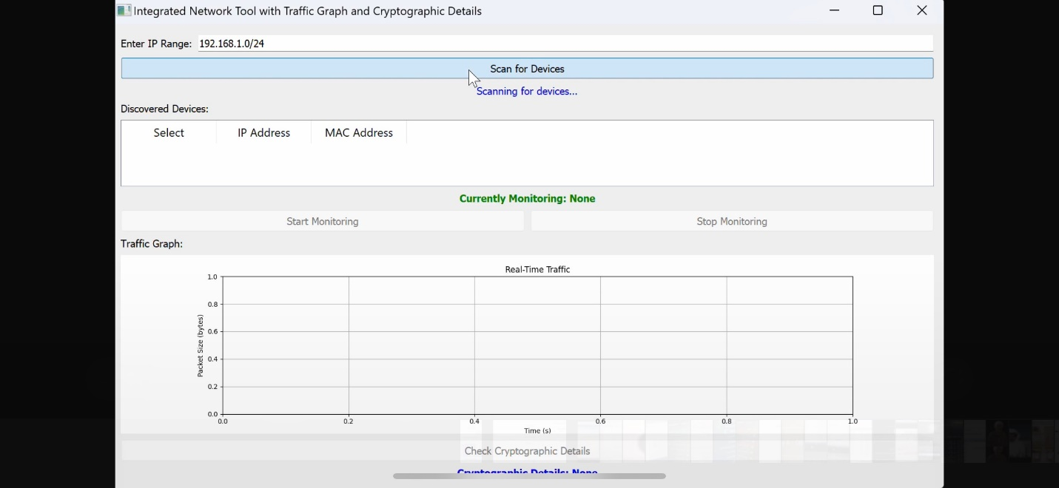
Figure 16: Scanning for IoT Devices.

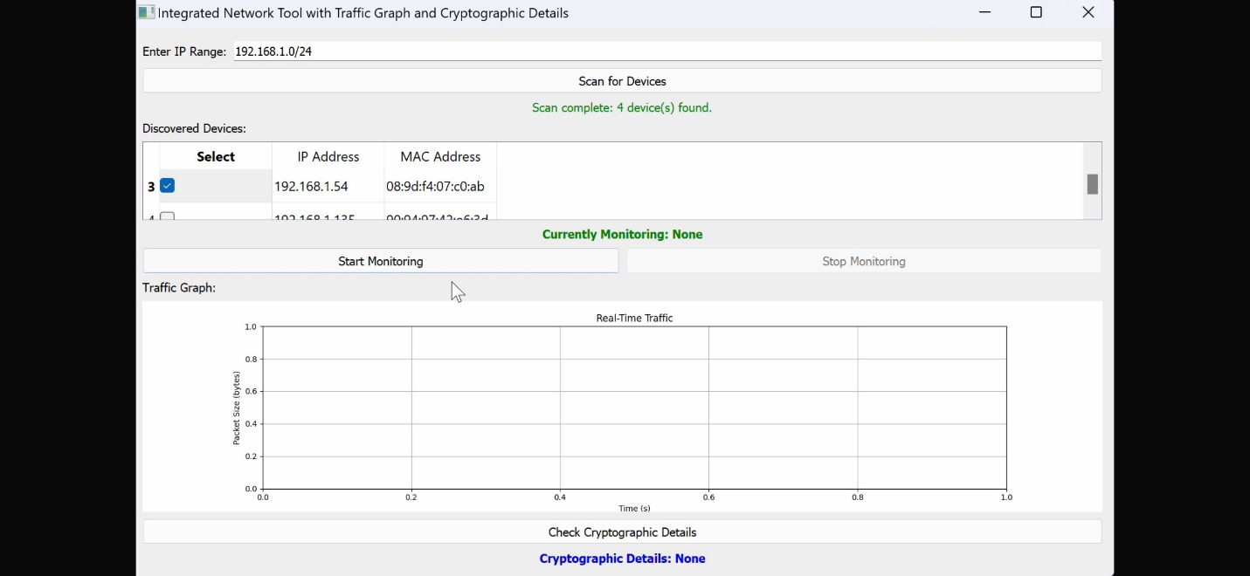
Figure 17: Selecting a Device from "Discovered Devices".
After selecting a target, the tool initiates traffic monitoring using a real-time packet sniffer (ARP Spoofing), visualizing the captured packet sizes over time in a live graph (Packet size in bytes per time in seconds). Monitoring can be manually stopped after sufficient data collection. In Figure 3, we have started Traffic Graph by initiating “ Start Monitoring”. In Figure 4, The traffic capturing is started and graph is shown for IoT Device Traffic. In Figure 5, we have stopped the traffic collection after a time by “Stop Monitoring”

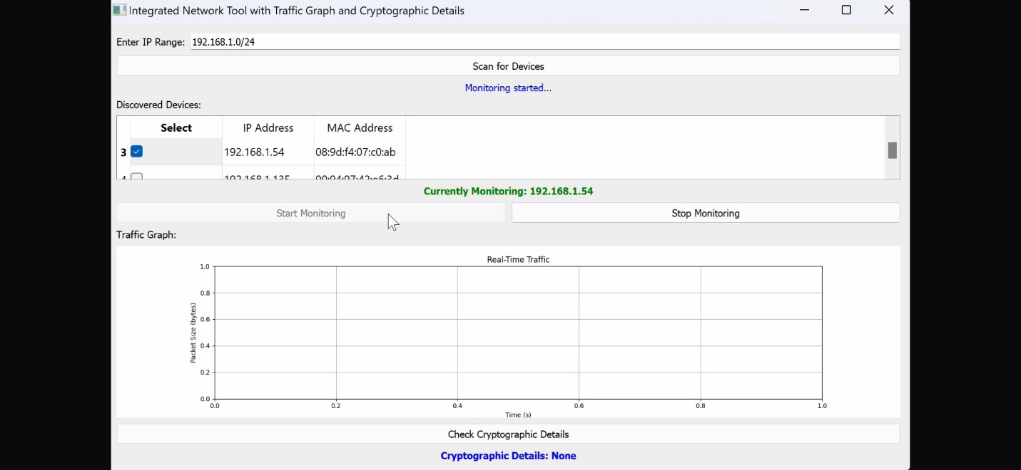
Figure 18: Capturing Traffic by "Start Monitoring".

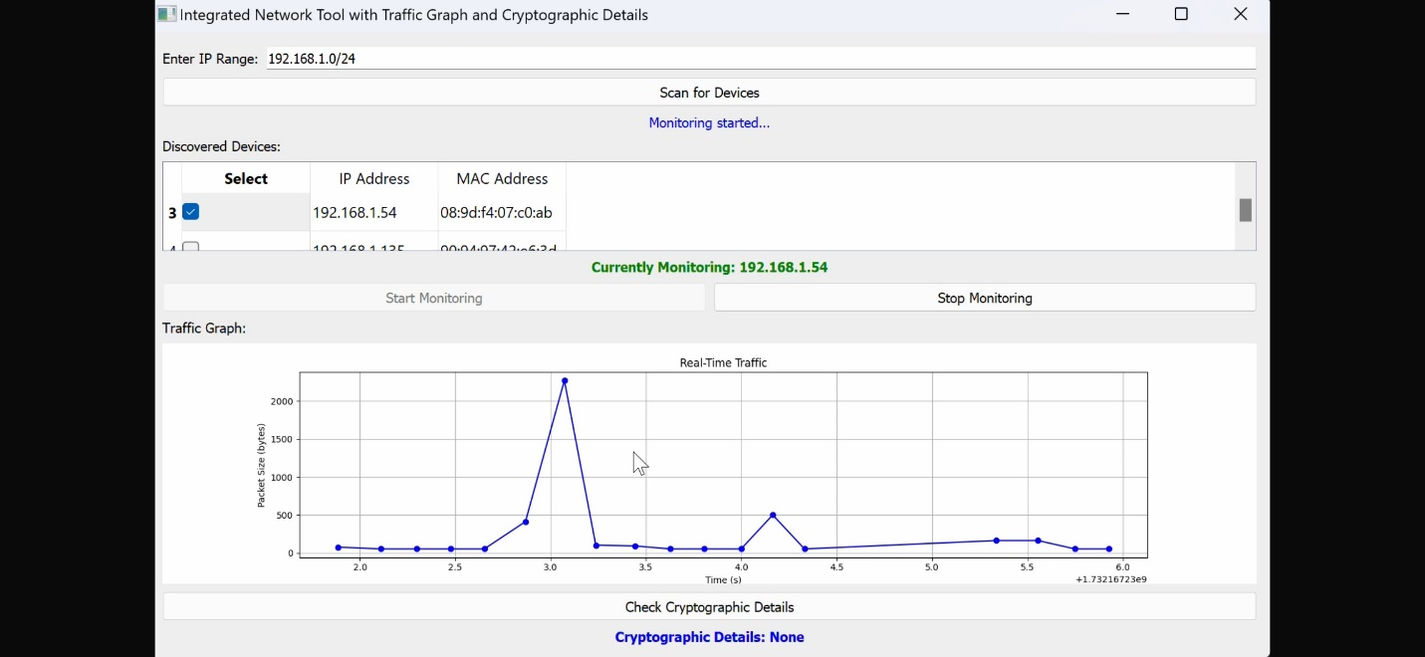
Figure 19: Sample of Collected Traffic.

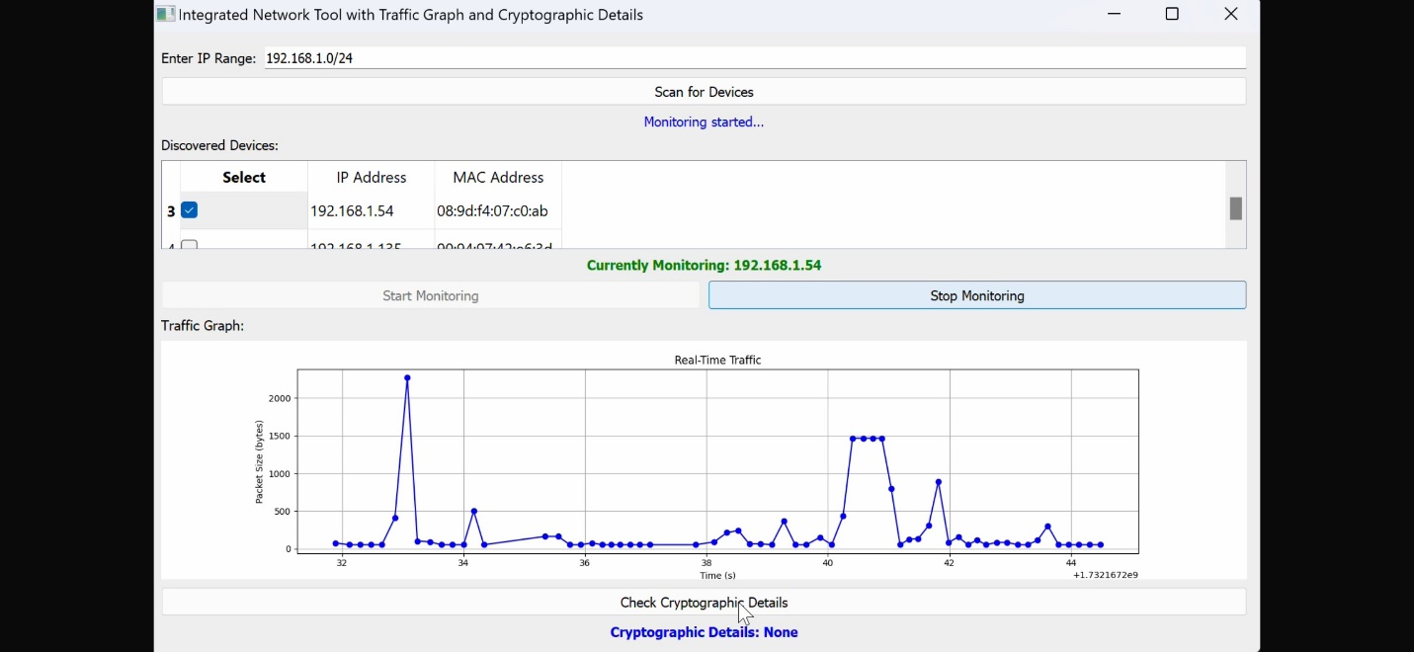
Figure 20: Stopping Traffic Collection by "Stop Monitoring".

For cryptographic analysis, the tool uses Nmap to scan open ports on the selected device(s), assessing encryption strength based on detected services (e.g., HTTPS/SSH for strong encryption or HTTP/Telnet for weak or no encryption). Finally, the results of this analysis are displayed in the GUI, providing users with insights into the cryptographic protocols and encryption security of the selected devices. In Figure 6, a graph of collected traffic is displayed for the collection time.

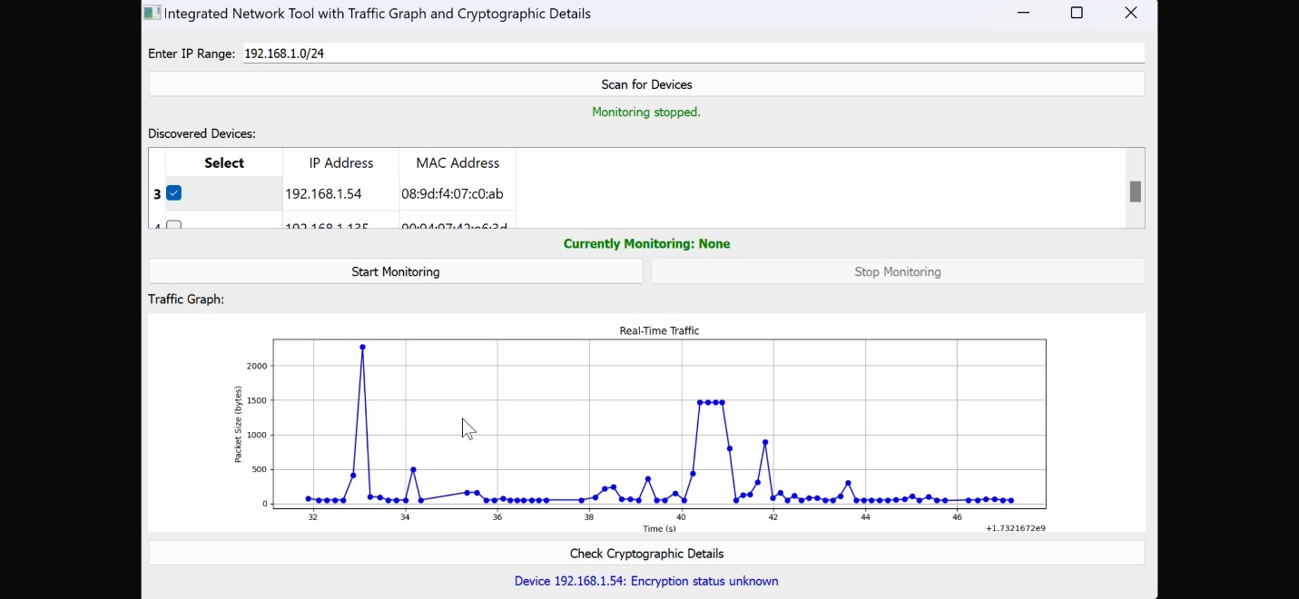
Figure 21: Results of Traffic Collection.

In Figure 7, we have connected to other device (Samsung TV), and we have carried out the traffic monitoring and cryptographic checking which has indicated weak or no encryption as well as detected protocols during the captured snap of traffic.

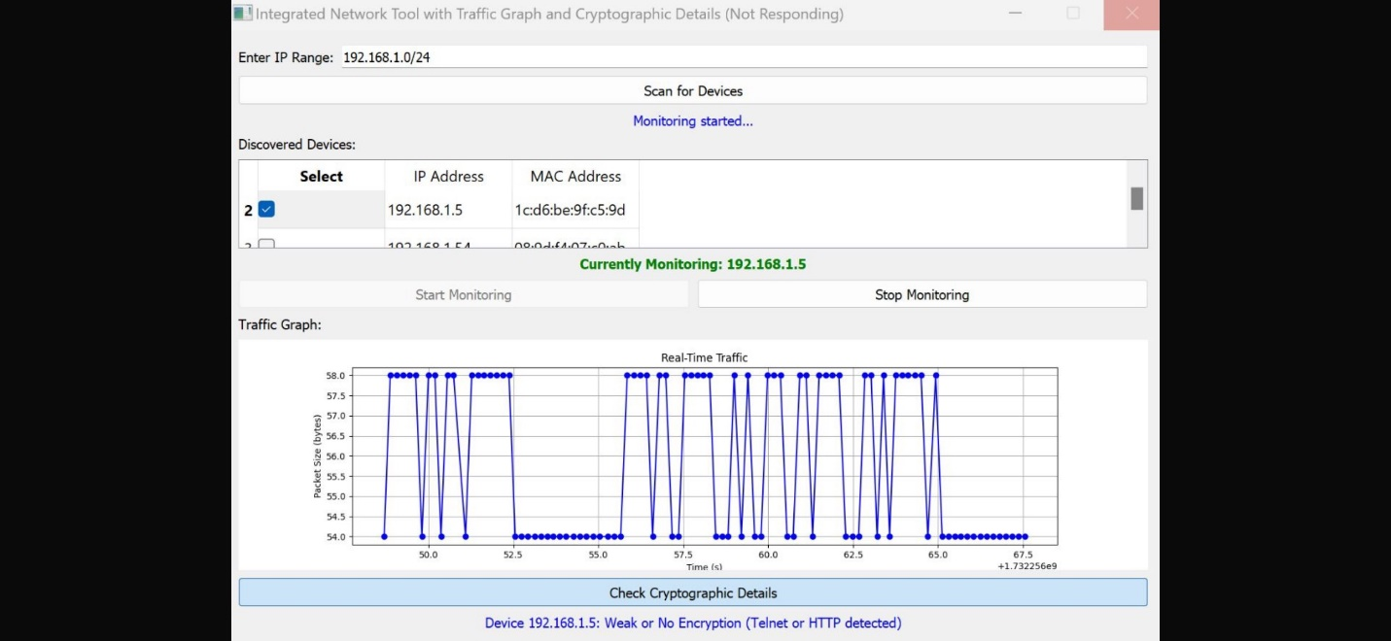
Figure 22: Checking Cryptographic Details for Different IoT Device.
Paper [7] was intended to create a large-scale, labeled dataset that facilitates research on IoT security and privacy by allowing users to analyze traffic from their devices and collect data for broader research purposes. Thereby, we have availed the tool and utilize it to provide IoT Devices Security and analysis tool.

